PROJECT REPORT

ON

Web Game System



Submitted by:

Nguyen Dong Duc Viet - HE150938

Nguyen Hoang Duong - HE150328

Nguyen Van Chuc - HE150618

Pham Anh Tuan - HE150543

Vu Van Duong - HE150773



1. **INTRODUCE**:
   1. Problem Statement:

Normally, when you want to find a game that suits your needs, players often look up on browser tools such as google chrome, bing, etc. to be able to search and download the game they like. Therefore, there is a need for websites that aggregate games of many developers to be able to optimize the search method for users. A web game used to connect users with games based on aspects: genre, genre, developer, ... Players can directly buy and download game titles. on the website and the amount spent will be transferred to the developer's wallet.

* 1. Case study:

The game system is built as an intermediary website used to connect users with the game. Each user will have to set up an account, including phone number and gmail to verify identity, password to ensure the security of the account.

For a single user, 80JS has a feature called a wallet where players can deposit and purchase existing games on the system. Some features during the use of the site are that players can upload profile pictures, view personal and update information, and view transaction history. An interesting feature of using the site is that the more games you buy, the higher your experience points and you will receive incentives when your level reaches a certain level.

When in the main interface of the website, users can search for games that have been sorted by genre, platform, popular games, free games or new games. When clicking on the game, users will see game information, game ratings, purchased or not. Users can add them to their favorites, what we call wish lists, as well as comment and rate games through our interface's review and comment system. At the same time, in the footer of the website, there will be top similar games that players can check out and use.

If the user wants to buy free games, the system will automatically download the game for them and add it to the list of available games. As for paid games, the system will put the games that players want to buy and make transactions through the button chart on the header page. And after payment, the user's profile page will have an order that stores the date of the transaction.

Besides, for admins who are also players, there is an admin page to manage games, users, companies and galleries. Admin can perform some functions like add, update or delete/restore. There is also a section where the admin can control the orders and their information on the admin home page.

* 1. Software Requirement & Framework:

Software Programming : Netbeans IDE 8.2 RC

Database Stored Software : SQL Server management studio

Front-end Framework : Bootstrap, Jquery

Programming Language : Java

Front-end : JSP

Back-end : Servlet

Operating System : Windows 10

1. **ENTITY RELATIONSHIP DIAGRAM**:
   1. Logical design:

The logical design of the website consists of four main parts: Home page, game page, information page, and admin page.

The interface starts with the home page, after logging in, you can open other link pages such as game page, pfrofile page and admin page for admin only.

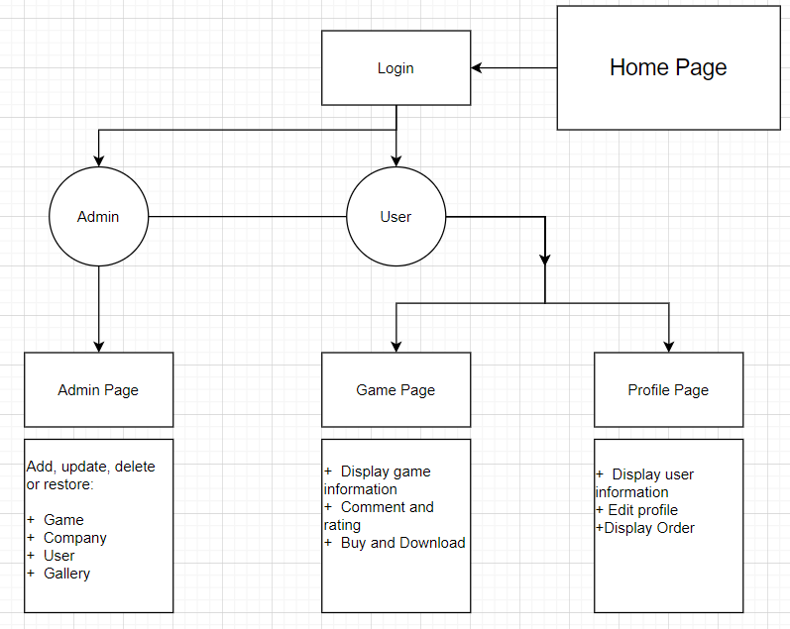

* 1. Physical design

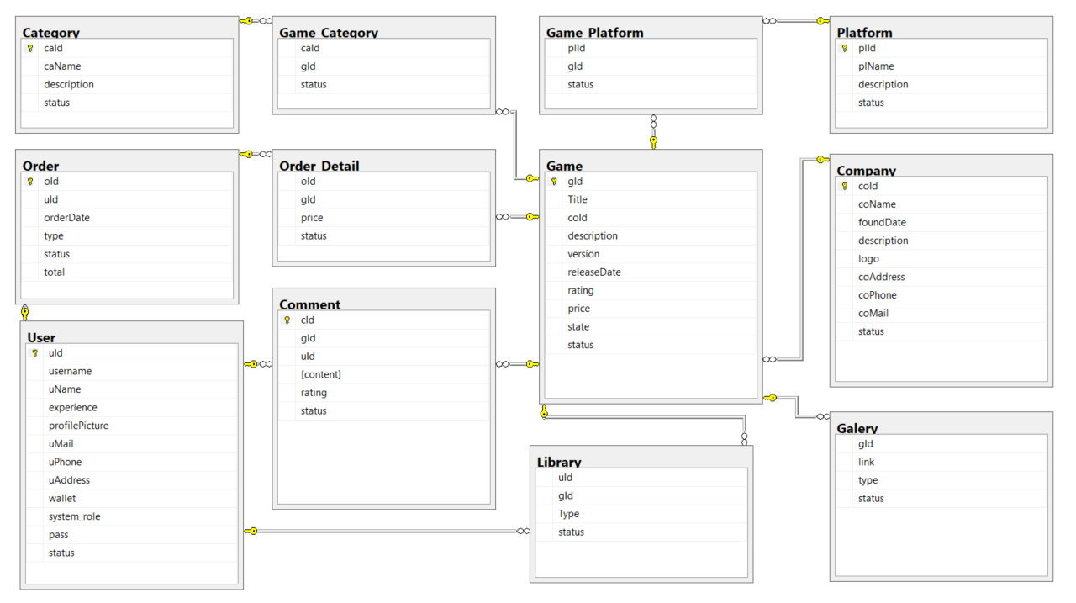

Table Details:

|  |  |  |  |  |
| --- | --- | --- | --- | --- |
| Table : Game | | | | Description |
| Column | Data Type | Constraint | Description |
| gId | int | identity(1,1) | Game’s ID | Game’s Data |
| Title | nvarchar(255) |  | Game’s title |
| coId | int | FOREIGN KEY (coId) REFERENCES dbo.[Company] (coId) | Company’s ID |
| description | nvarchar(1027) |  | Description |
| version | nvarchar(55) |  | Game’s Version |
| releaseDate | date | releaseDate <= getDate() | Game’s release date |
| rating | int | rating >= 0 AND rating <= 100 | Game’s Rating |
| price | money | price>=0 | Game’s Price |
| state | nvarchar(55) |  | Game state: Coming Soon, Available,… |
| status | bit |  | Availability of data |

|  |  |  |  |  |
| --- | --- | --- | --- | --- |
| Table : Company | | | | Description |
| Column | Data Type | Constraint | Description |
| coId | int | identity(1,1) | Company’s ID | Company’s Data; The game maker |
| coName | nvarchar(63) |  | Company’s name |
| foundDate | date | foundDate <= getDate() | Company’s foundation date |
| description | nvarchar(1027) |  | Company’s description |
| logo | nvarchar(255) |  | Company’s logo |
| coAddress | nvarchar(511) |  | Company’s address |
| coPhone | nchar(10) |  | Company’s phone |
| coMail | nvarchar(255) |  | Company’s mail |
| status | bit |  | Availability of data |

|  |  |  |  |  |
| --- | --- | --- | --- | --- |
| Table : User | | | | Description |
| Column | Data Type | Constraint | Description |
| uId | int | identity(1,1) | User’s ID | User’s data;  The User in of the site |
| username | nvarchar(63) | UNIQUE | User’s login name |
| uName | nvarchar(63) |  | User’s display name |
| experience | int | experience>=0 | User’s Experience |
| profilePicture | nvarchar(255) |  | User’s Profile Picture |
| uMail | nvarchar(63) |  | User’s mail |
| uPhone | nchar(10) |  | User’s phone |
| uAddress | nvarchar(511) |  | User’s address |
| wallet | money |  | User’s balance |
| system_role | nvarchar(63) |  | User’s role |
| pass | nvarchar(255) |  | User’s password |
| status | bit |  | Availability of data |

|  |  |  |  |  |
| --- | --- | --- | --- | --- |
| Table : Category | | | | Description |
| Column | Data Type | Constraint | Description |
| caId | int | identity(1,1) | Category’s Id | Category of games |
| caName | nvarchar(63) |  | Category’s name |
| description | nvarchar(1027) |  | Description |
| status | bit |  | Availability of data |

|  |  |  |  |  |
| --- | --- | --- | --- | --- |
| Table : Platform | | | | Description |
| Column | Data Type | Constraint | Description |
| plId | int | identity(1,1) | Platform’s Id | Platform of games |
| plName | nvarchar(63) |  | Platform’s name |
| description | nvarchar(1027) |  | Description |
| status | bit |  | Availability of data |

|  |  |  |  |  |
| --- | --- | --- | --- | --- |
| Table : Galery | | | | Description |
| Column | Data Type | Constraint | Description |
| gId | int | FOREIGN KEY (gId) REFERENCES dbo.[Game](gId) | Game’s ID | Materials of games |
| link | nvarchar(255) |  | Link to the material |
| type | nvarchar(15) |  | Type of Gallery : img-gp, img-po, vid-trailer,… |
| status | bit |  | Availability of data |

|  |  |  |  |  |
| --- | --- | --- | --- | --- |
| Table : Comment | | | | Description |
| Column | Data Type | Constraint | Description |
| cId | int | identity(1,1) | Comment’s ID | User’s comments on games |
| gId | int | FOREIGN KEY ([gId]) REFERENCES dbo.[Game]([gId]) | Game’s ID |
| uId | int | FOREIGN KEY ([uId]) REFERENCES dbo.[User]([uId]) | User’s ID |
| content | nvarchar(1027) |  | Content of the comment |
| rating | int | rating >= 0 AND rating <= 100 | Rating of the comment |
| status | bit |  | Availability of data |

|  |  |  |  |  |
| --- | --- | --- | --- | --- |
| Table : Game_Category | | | | Description |
| Column | Data Type | Constraint | Description |
| caId | int | FOREIGN KEY (caID) REFERENCES dbo.[Category](caId) | Category’s ID | Relation between Categories and Games |
| gId | int | FOREIGN KEY (gID) REFERENCES dbo.[Game](gId) | Game’s ID |
| status | bit |  | Availability of data |

|  |  |  |  |  |
| --- | --- | --- | --- | --- |
| Table : Game_Platform | | | | Description |
| Column | Data Type | Constraint | Description |
| plId | int | FOREIGN KEY (plID) REFERENCES dbo.[Platform](plId) | Platform’s ID | Relation between Platforms and Games |
| gId | int | FOREIGN KEY (gID) REFERENCES dbo.[Game](gId) | Game’s ID |
| status | bit |  | Availability of data |

|  |  |  |  |  |
| --- | --- | --- | --- | --- |
| Table : Library | | | | Description |
| Column | Data Type | Constraint | Description |
| uId | int | FOREIGN KEY ([uId]) REFERENCES dbo.[User]([uId]) | User’s ID | Relation between Users and Games |
| gId | int | FOREIGN KEY (gId) REFERENCES dbo.[Game](gId) | Game’s ID |
| Type | nvarchar(63) |  | Type of relation: owned, wishlist, follow.. |
| status | bit |  | Availability of data |

|  |  |  |  |  |
| --- | --- | --- | --- | --- |
| Table : Order | | | | Description |
| Column | Data Type | Constraint | Description |
| oId | int | identity(1,1) | Order’s ID | Orders of Users |
| uId | int | FOREIGN KEY ([uId]) REFERENCES dbo.[User]([uId]) | User’s ID |
| orderDate | date | orderDate <= getDate() | Order’s Date |
| type | nvarchar(63) |  | Order’s Type: Recharge, topup, buygame,… |
| total | money | total>=0 | Final Total of the order |
| status | bit |  | Availability of data |

|  |  |  |  |  |
| --- | --- | --- | --- | --- |
| Table : Order_Detail | | | | Description |
| Column | Data Type | Constraint | Description |
| oId | int | FOREIGN KEY ([oId]) REFERENCES dbo.[Order]([oId]) | Order’s ID | Detail of orders |
| gId | int | FOREIGN KEY ([gId]) REFERENCES dbo.[Game]([gId]) | Game’s ID |
| price | money | price>=0 |  |
| status | bit |  | Availability of data |

1. **SYSTEM DESIGN**:

The system is designed according to the MVC model, including three parts: Model, Views and Controller.

Controller is an application flow control class, receiving user requests through HTTP headers, and then forwarding it to the classes in charge of directly handling the request.

Controllers include:

* Front Controller directly handles user requests for web sites, giving a list of game lists sorted by popular, free, newest,...
* Dispatcher: Dispatch the navigation of the controls at a higher level. The services sent from the jsp pages in the view will be sent to the controller for processing, then the response to that jsp page or to other jsp pages by sending dispatcher
* Request: process part of input data at GET, POST level
* Session: Handles the input data at the session level, used to save the user profile properties after login.

The Controller receives input data through the View, then calls the corresponding Model, and then gets the results returned from this Model. Next, an appropriate View will be selected. Controller will forward data to the View for processing.

Model is the layer that provides data, data-related services, and logical processing problems.

The model not only retrieves data from the database, but also uses it to check for exceptions, file system, and system memory.

View is a class that defines how data is presented. View consists of two main parts:

* Template file: defines the structure and way of presenting data to the user. For example, layout, colors, frames.
* Logical part: dealing with how to apply data to the presentation structure.

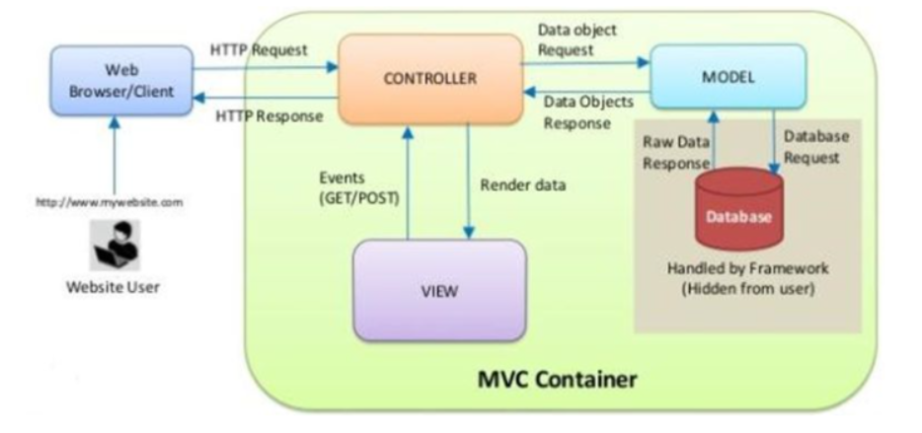

1. **SCREENSHOT**:

* Home Page (haven’t logged in)

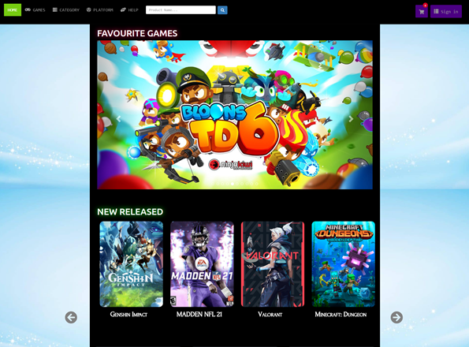

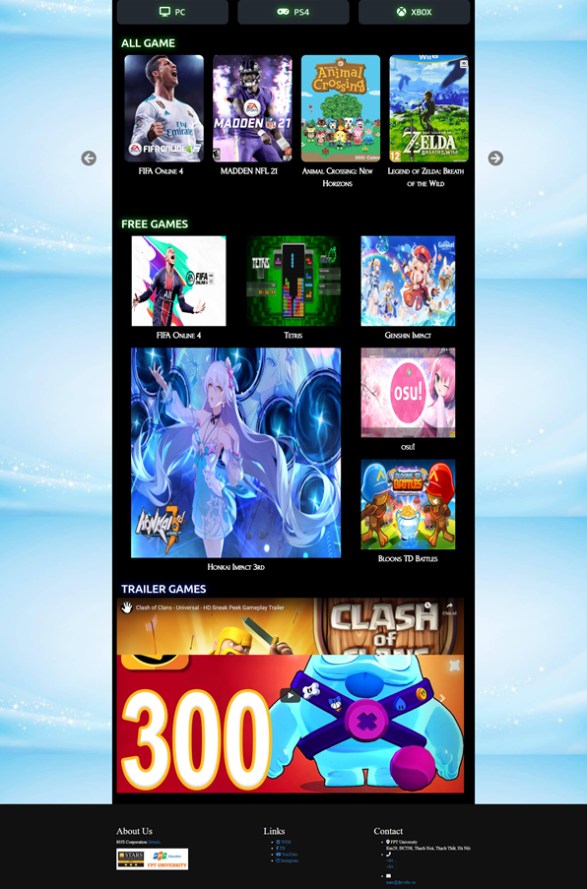

* Login Page

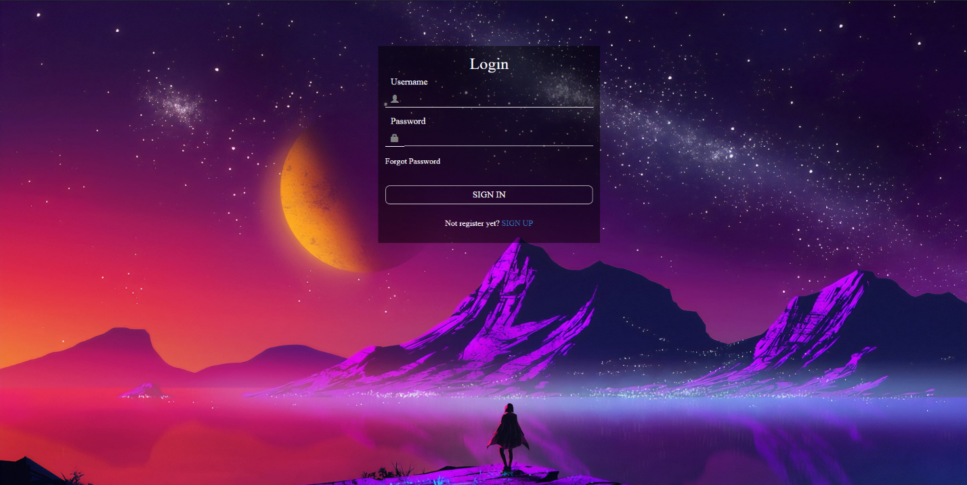

* Register Page

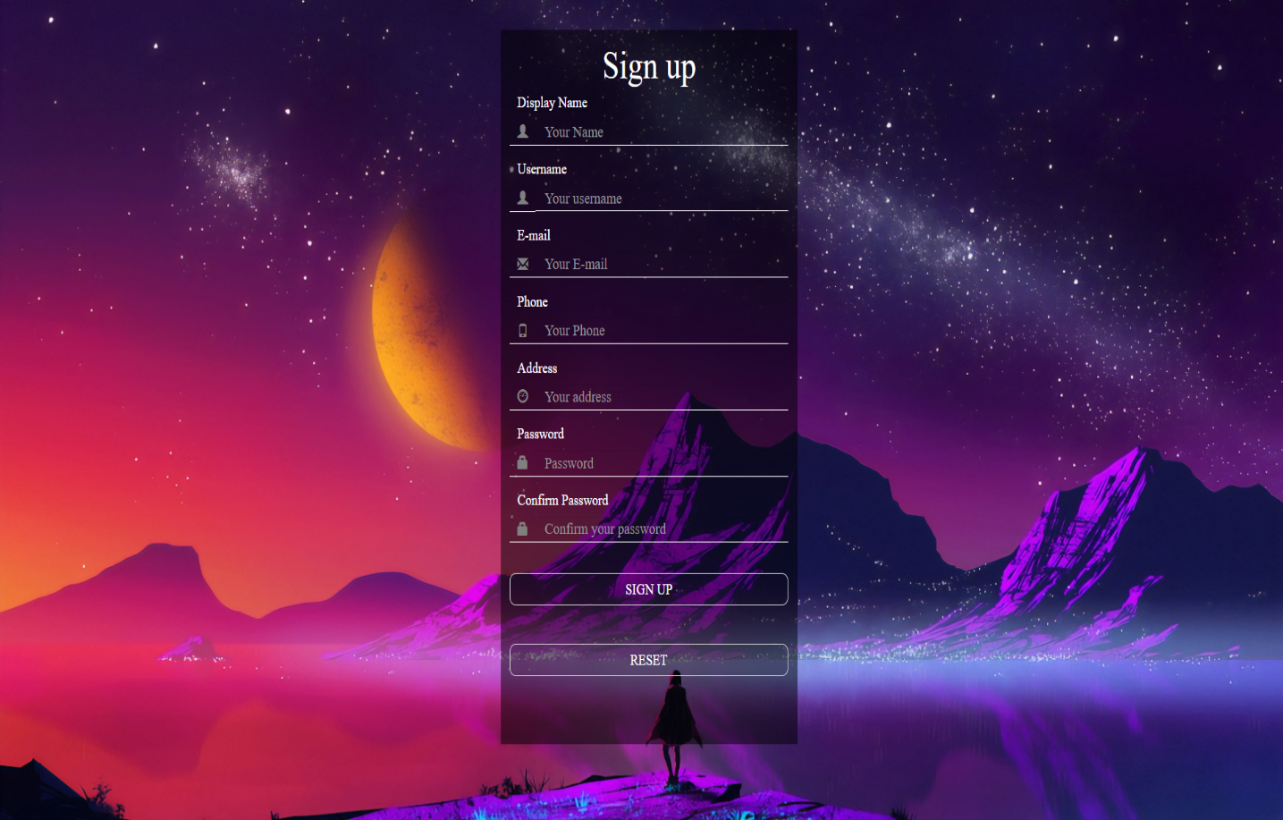

* Forgot Password Page

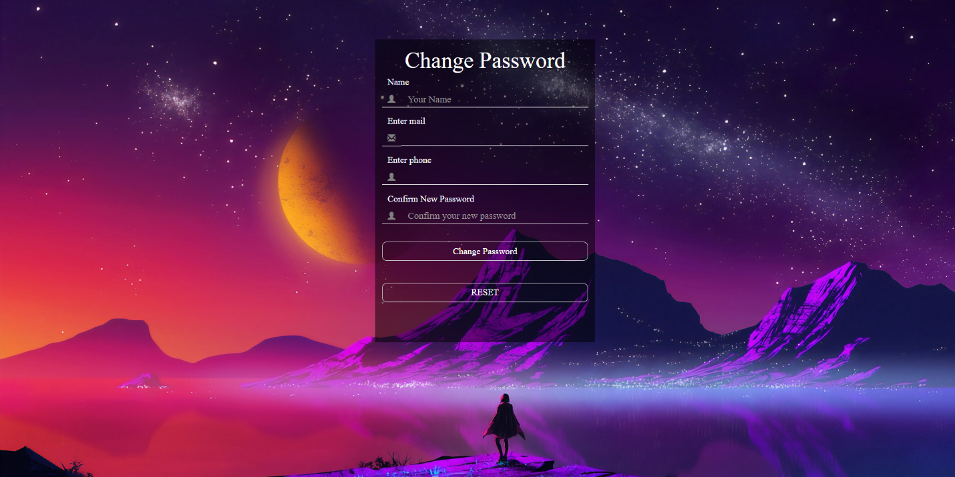

* Home Page (logged in, just have change in header)

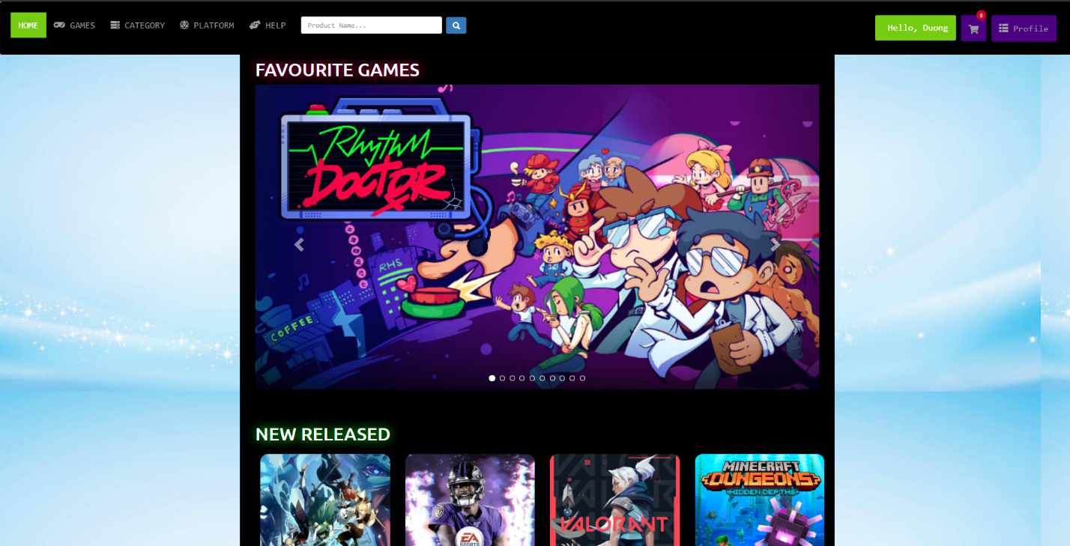

* Change Password

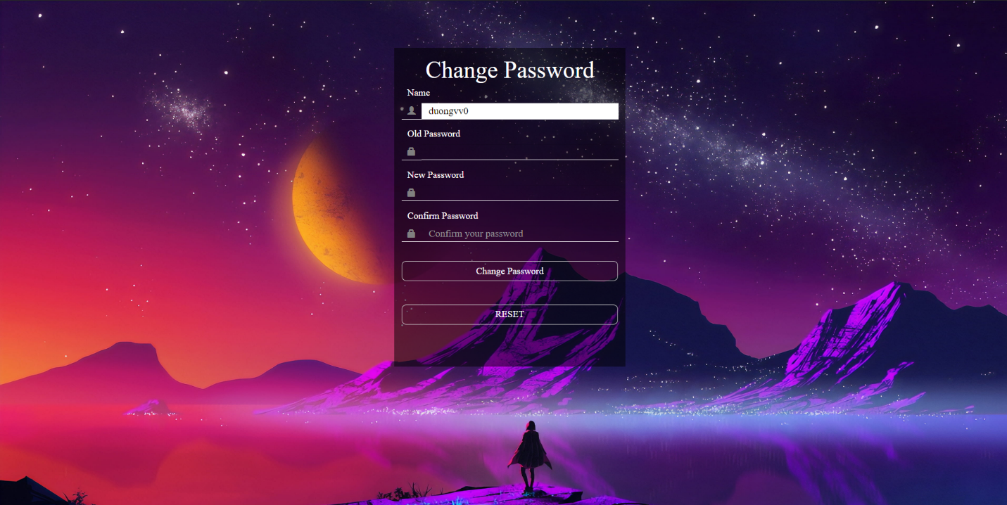

* Game Page

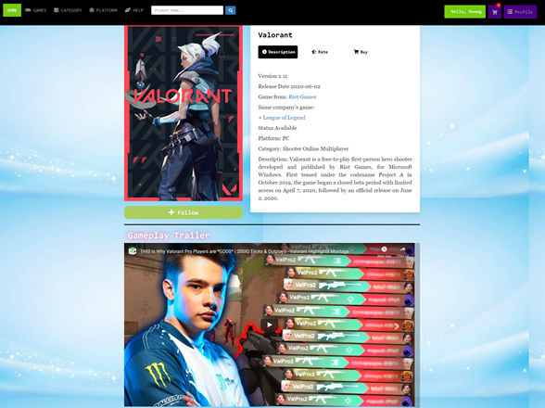

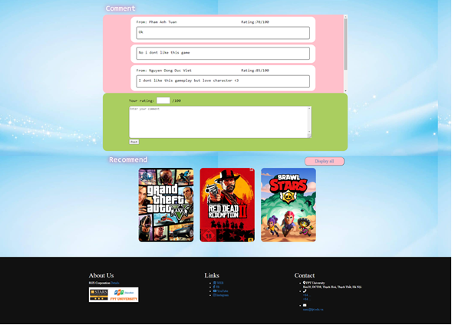

* Game Storage Page

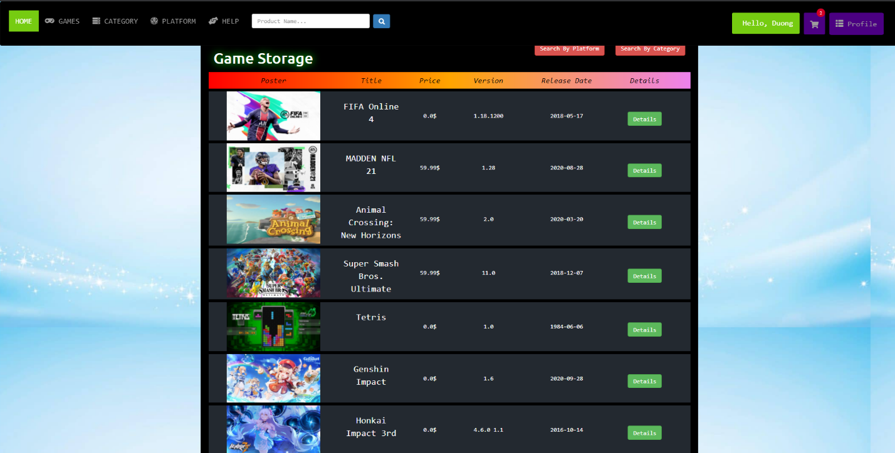

* Cart Page

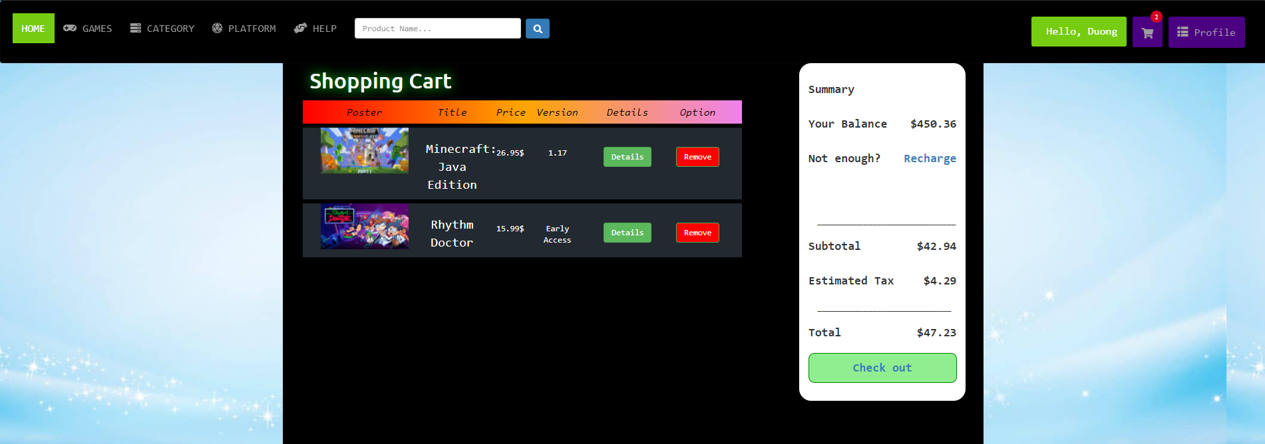

* Profile Page

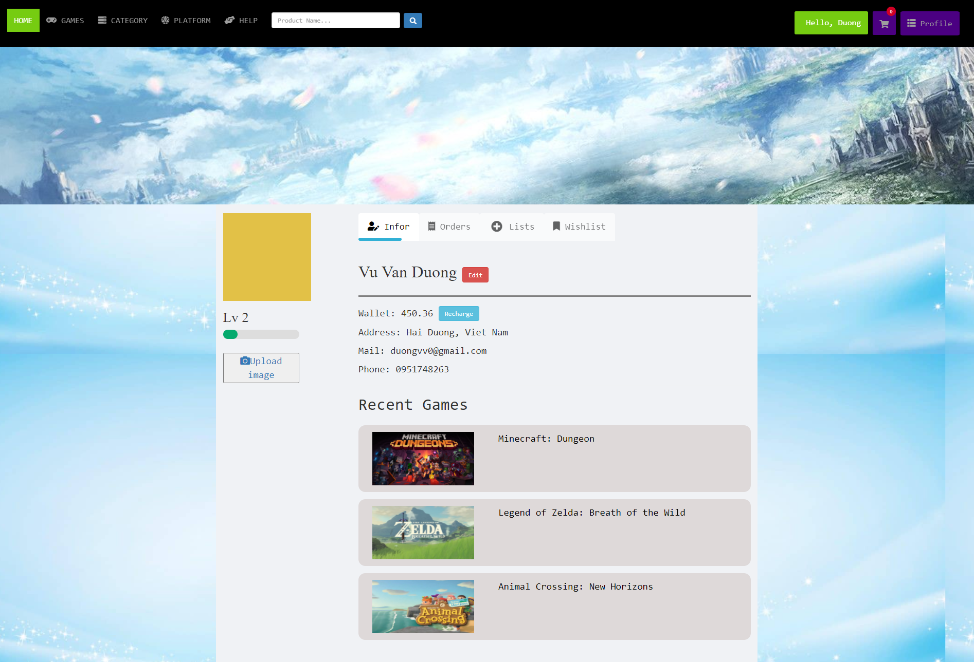

* Order Page

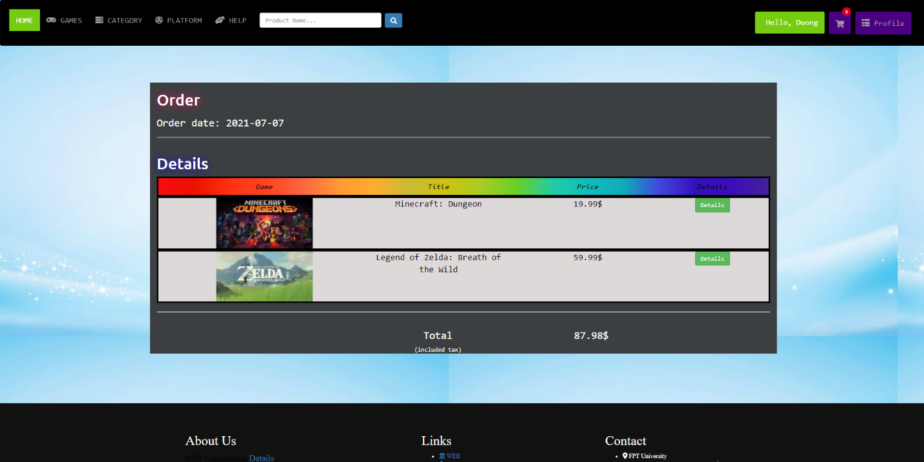

* Edit page

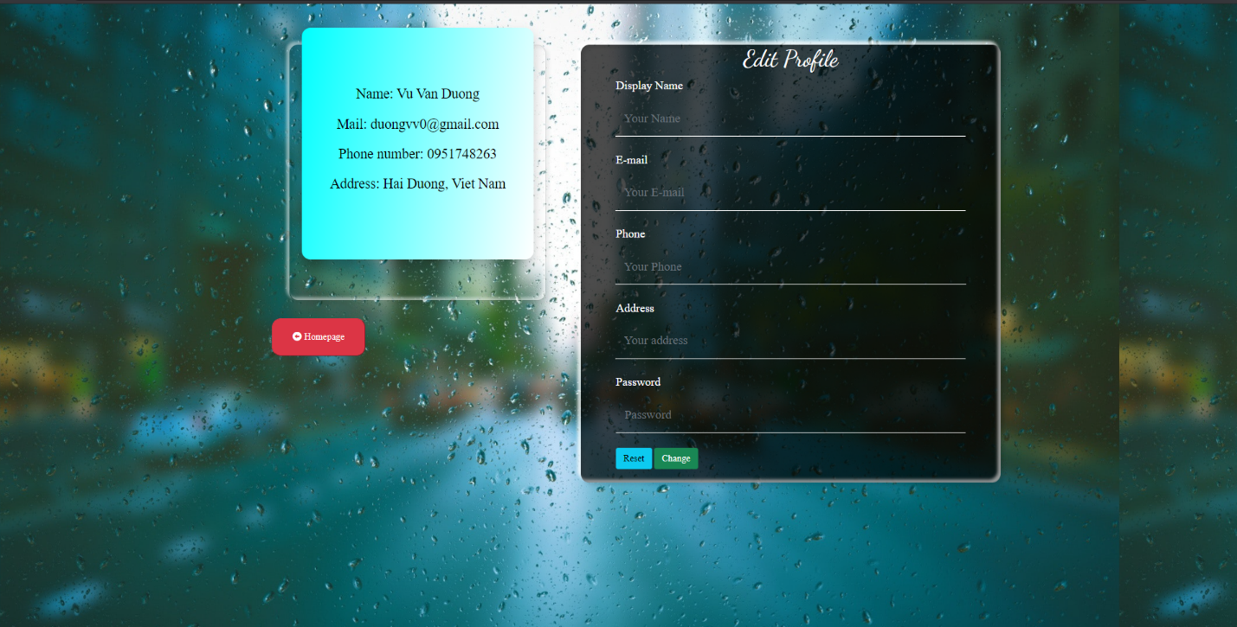

* Recharge Page

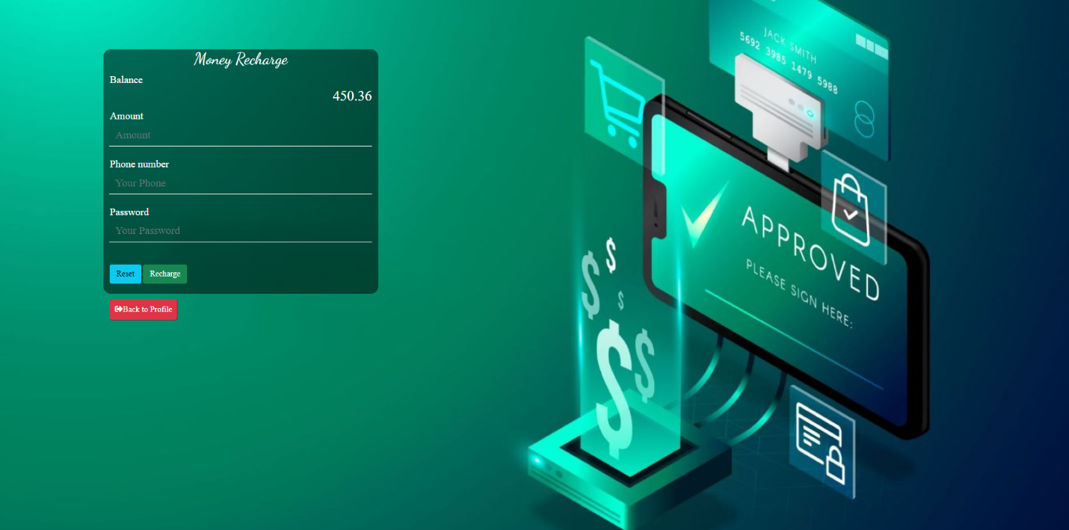

* Admin Page

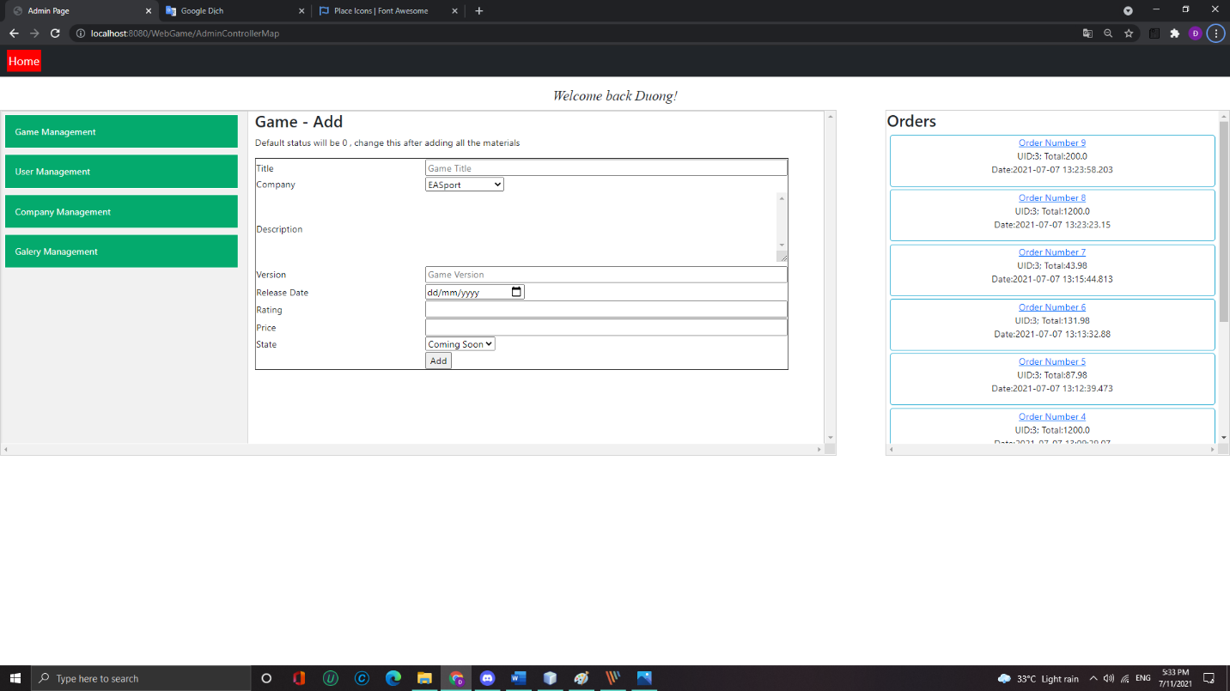

* About Us

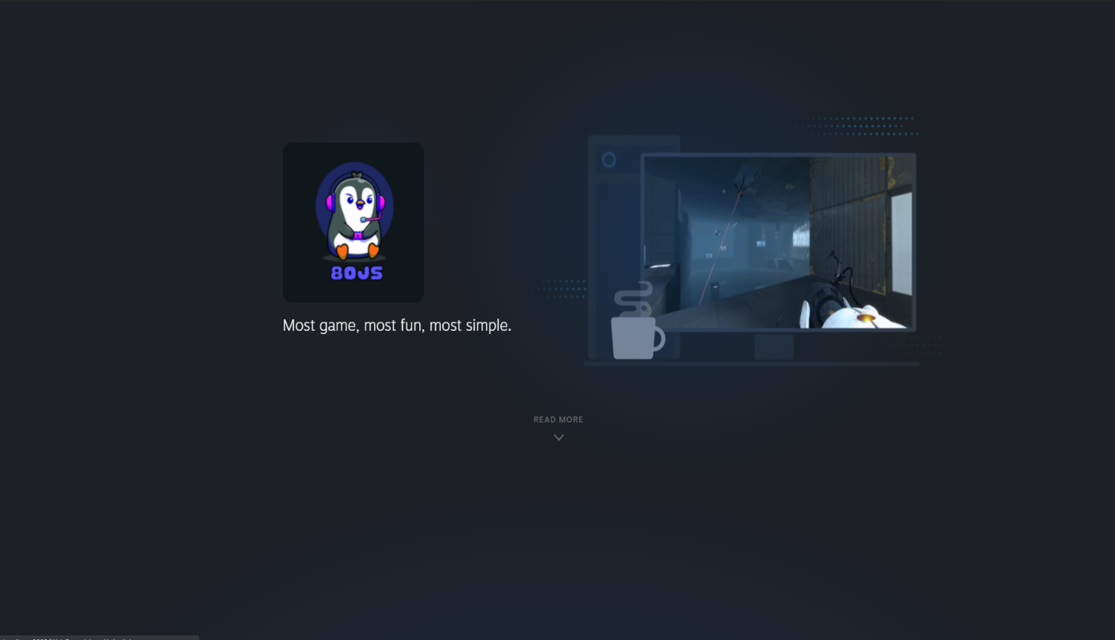

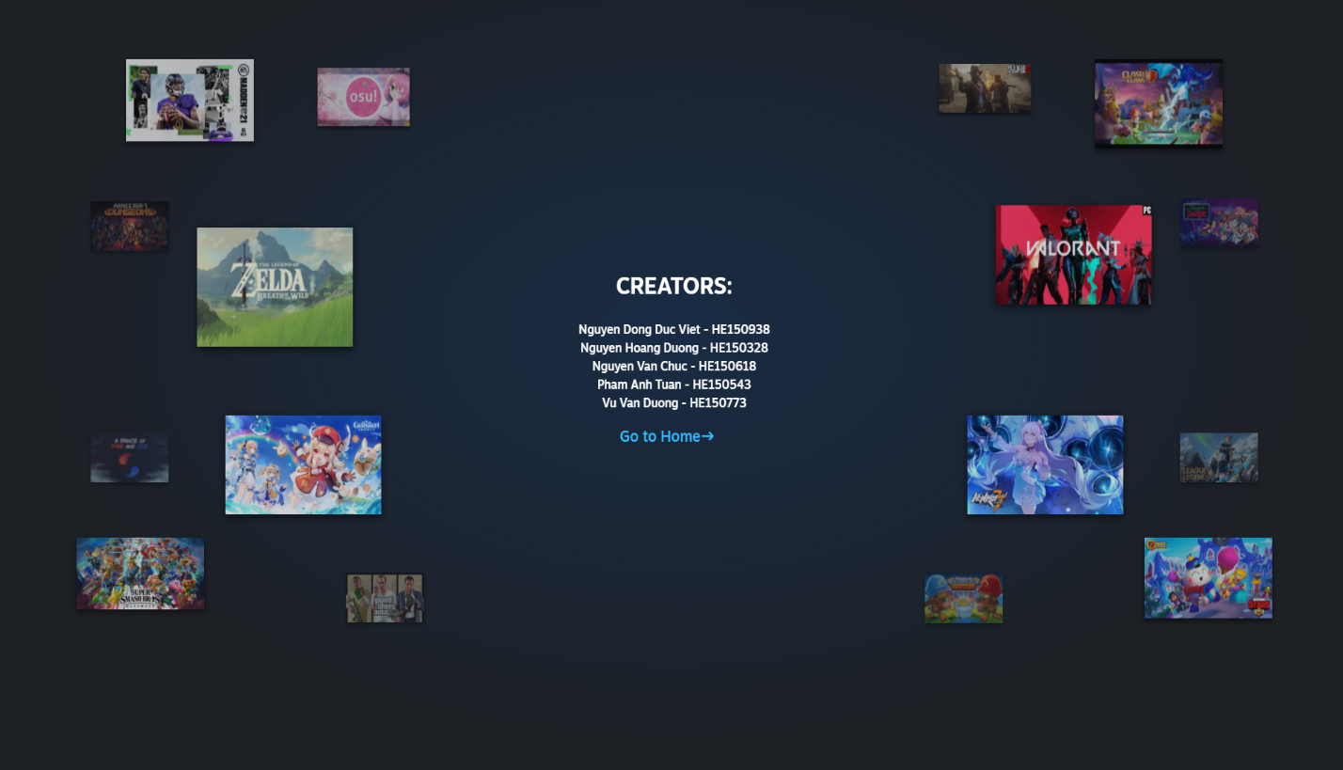

1. **CONCLUSION AND DISCUSSION**:
   1. Conclusion

Advantages:

+ Tight model design, easy to use

+ Many features and utilities

+ Strict management model

Weakness:

+ Poor security, security rules are not up to the right standards

+ Simple interface, not professional, there are spelling errors

* 1. Discussion

Through this project, we have learned how to design applications using a simple MVC model, each member learns and practices with the same tasks:

+ Development: Learn to be developers while working with Models. Make full use of the knowledge and skills of programmers related to data processing algorithms, database management.

+ Design: Designers work directly with the View layer, responsible for creating the look of the application. Experience working with HTML, CSS, JavaScript and Graphic Design is required

+ Merge: exist in the Controller class. The main purpose is to bring developers and designers together. Integrators need to understand how an application is organized.

To improve the website in the coming time, 80JS will continue to edit the interface of the webgame to better suit the needs of users in the near future with some new features, adding new frameworks and technologies. Moreover, will proceed to put the website on the hosting server and start connecting with real users.